**Describe Python Library Requirements (describe classes and methods used)**

|  |  |  |  |
| --- | --- | --- | --- |
| MODULE | CLASS | OBJECT VARIABLE | METHODS |
|  | MAKEBOOKING() | Treatment1,treatment2,treattment3  Trearment4….treatment25 | Treatment choice |
|  | STR() | Monday,Tuesday,wensday  ,Thursday,friday | Day choice |
|  | Int() | Weekdays,monaytes,tuesdates,tuesdates  Wednesdaydates,thursdaytes,fridaydates  Saturdaytes,times | date choice |
|  | showBookings() | Blockweekdday… | .append |
|  | Len() |  |  |

**the program (include variables and data types used) - Describe operations to be performed**

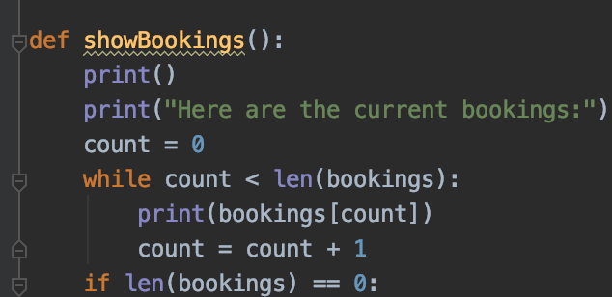

We use count = count +1 to add each loop thought .  variable count is initialized to 0 and then incremented each time the loop body is executed. When the loop exits, count contains the result – the total number of times the loop body was executed, which is the same as the number of digits.

count += 1 is an abreviation for count = count + 1 . The increment value does not have to be 1:

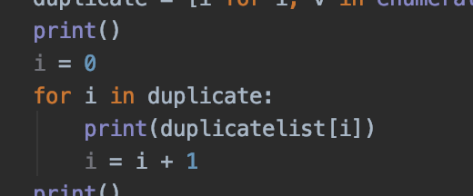

We use (i) to duplicate the list of the element

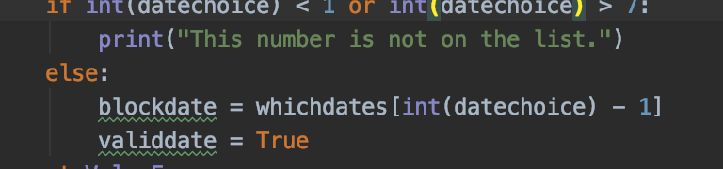

**(functions and computations) - Describe the outputs of the program(include variables and data**

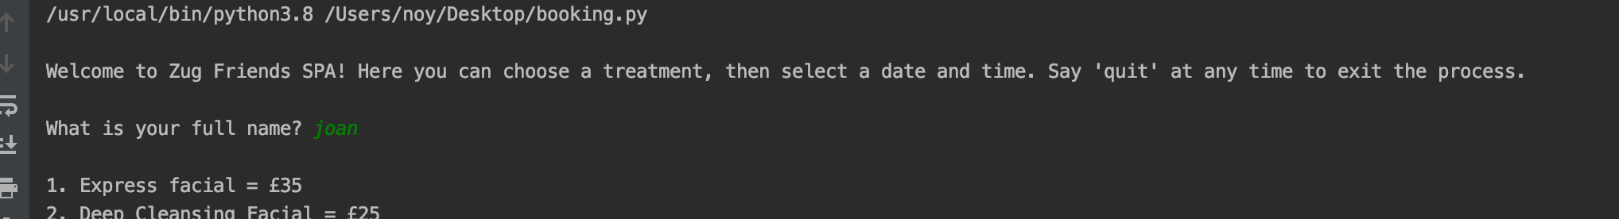

This code starts by giving the user a ‘Welcome’ message, letting them know that they are in a booking system, and that they can quit at any time by simply typing ‘quit’. ‘QUIT’ and ‘Quit’ are also accepted. For most stages of the booking, this command will allow them to exit. The only time they can’t use this command is when having to type a Yes/No answer, or while entering their contact email after confirming their booking time/date.

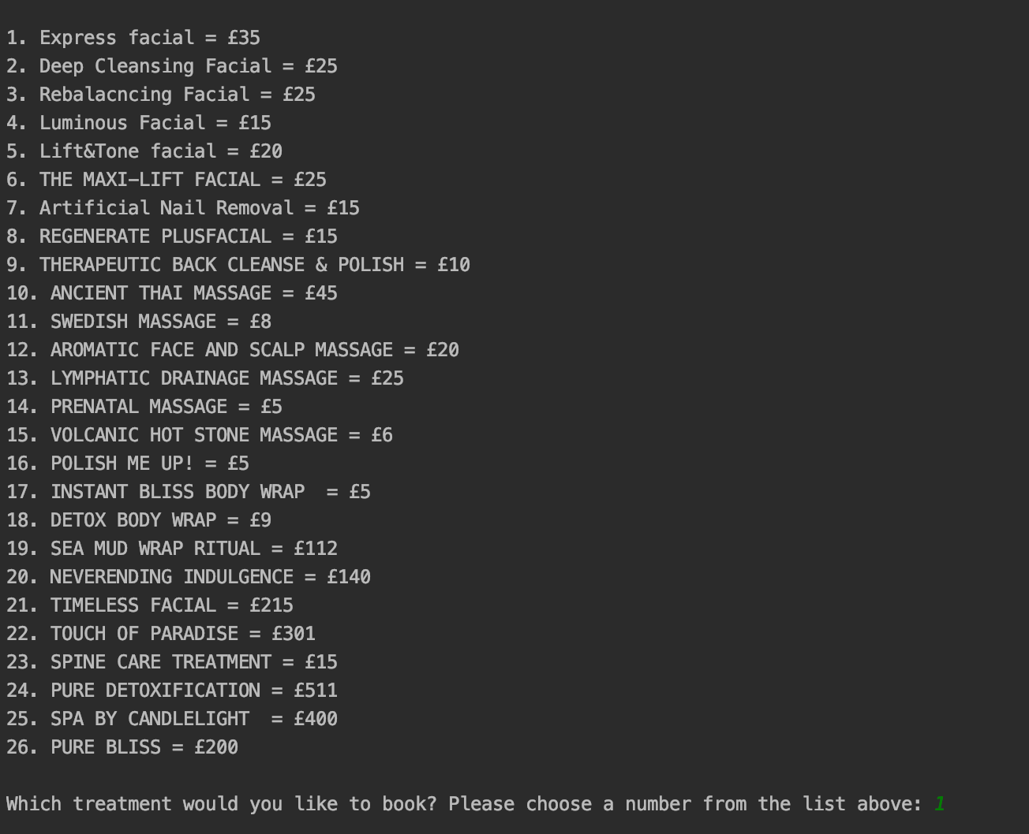

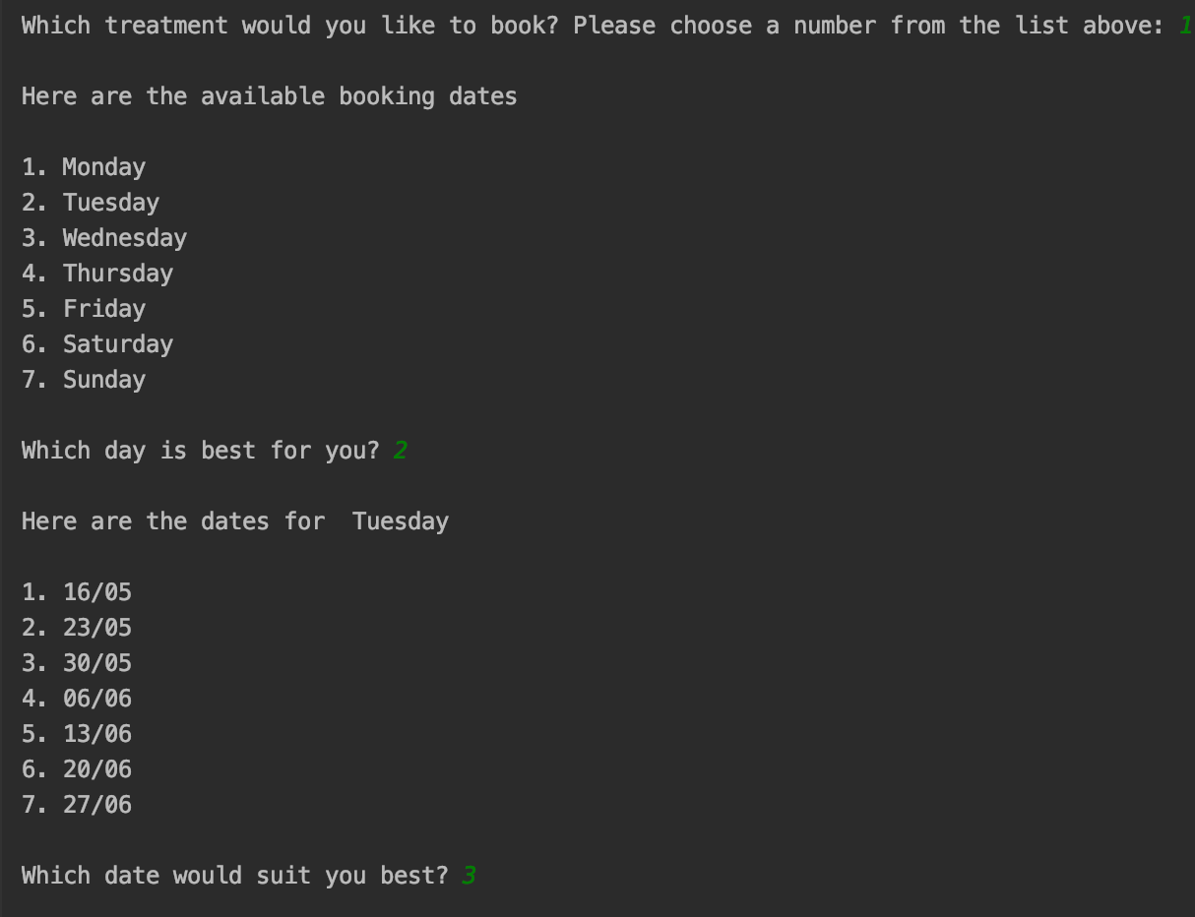

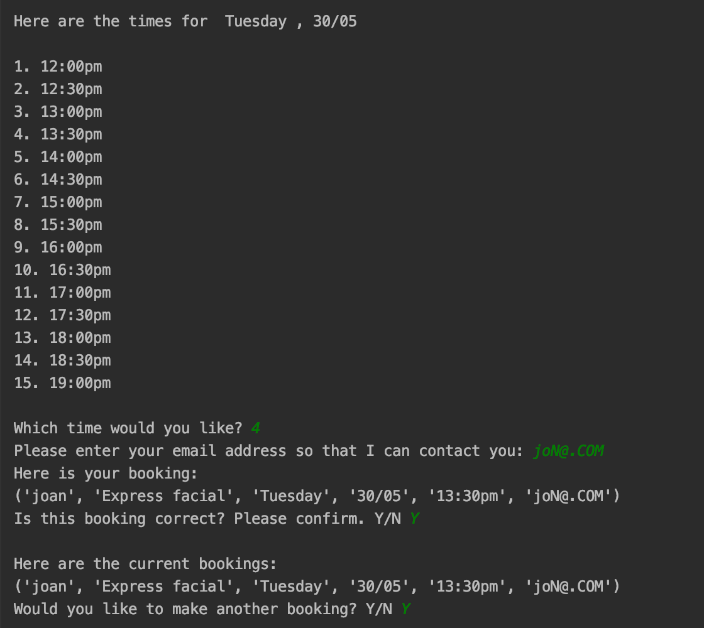

After the welcome message, the user enters their name. This is then stored as a variable which will be combined with their date and time choice and be put into the booking list. The name ‘noy’ is set as the admin username, meaning that if this is typed in, a password box will appear. In short, it is a hidden admin login method. If the password is entered incorrectly, the user will be prompted to enter it again until it is correct.

If NOT logged in, the booking algorithm will continue. The user will be shown a list of weekdays (Monday – Sunday) with corresponding numbers, and will have to type in the number of the weekday they would like. This is then set in a variable as their weekday choice.